https://www.geeksforgeeks.org/dsa/complete-binary-tree/

What is a Complete Binary Tree?
A complete binary tree is a special type of binary tree where all the levels of the tree are filled completely except the lowest level nodes which are filled from as left as possible.

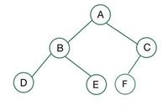
- Degree of a node - Number of children of a particular parent. Example- Degree of A is 2 and Degree of C is 1. Degree of D is 0.
- Internal/External nodes - Leaf nodes are external nodes and non leaf nodes are internal nodes.
- Level - Count nodes in a path to reach a destination node. Example- Level of node D is 2 as nodes A and B form the path.
- Height - Number of edges to reach the destination node, Root is at height 0. Example - Height of node E is 2 as it has two edges from the root.

- A complete binary tree is said to be a proper binary tree where all leaves have the same depth.
- Level - Count nodes in a path to reach a destination node. Example- Level of node D is 2 as nodes A and B form the path.
- Height - Number of edges to reach the destination node, Root is at height 0. Example - Height of node E is 2 as it has two edges from the root.

- In a complete binary tree number of nodes at depth d is 2d.
- In a complete binary tree with n nodes height of the tree is log(n+1).
- All the levels except the last level are completely full.
- For a given height h, the maximum number of nodes is 2h+1-1.
- 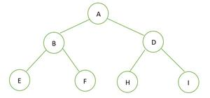
- The height of the given binary tree is 2 and the maximum number of nodes in that tree is n= 2^{h}+1-1 = 2²+1-1 = 2³-1 = 7.

If the parent is it index i so the left child is at 2i+1 and the right child is at 2i+2.
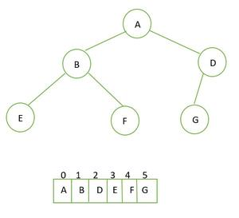

Full Binary Tree vs Complete Binary tree:
For a full binary tree, every node has either 2 children or 0 children.

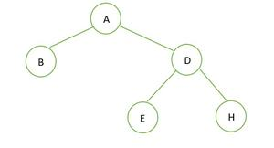
In the given binary tree there is no node having degree 1, either 2 or 0 children for every node, hence it is a full binary tree.

A Full Binary Tree (also known as a Proper or Plane Binary Tree) is a specialized tree structure where every node has either zero or two children. In this structure, no node can ever have exactly one child.

Inorder traversal is a depth-first traversal algorithm used to visit nodes in a binary search tree in a specific sequential order: left subtree, root node, then right subtree. This traversal technique follows the Left-Root-Right pattern, making it particularly valuable for binary search trees as it visits nodes in ascending sorted order.

1. What is the time complexity of an inorder traversal?
The time complexity is O(n), where n is the number of nodes in the tree, because each node is visited exactly once during the traversal process.

2. What is the space complexity of inorder traversal?
The space complexity is O(h), where h is the height of the tree, due to the recursive call stack. In the worst case (skewed tree), this becomes O(n), while in a balanced tree, it’s O(log n).

3. Why does inorder traversal produce a sorted output for binary search trees?
Inorder traversal visits nodes in Left-Root-Right order. In a binary search tree, all nodes in the left subtree are smaller than the root, and all nodes in the right subtree are larger. This property ensures that nodes are processed in ascending order. an

4. Can inorder traversal be implemented iteratively?
Yes, inorder traversal can be implemented iteratively using a stack data structure to simulate the recursive call stack, which can be more memory-efficient for very deep trees.

5. How does inorder traversal compare to preorder and postorder traversals?
Inorder (Left-Root-Right) is most useful for BSTs to get sorted data, preorder (Root-Left-Right) is used for tree copying and expression parsing, while postorder (Left-Right-Root) is used for tree deletion and expression evaluation.

Deletion in Binary Search Tree
https://www.log2base2.com/data-structures/tree/remove-an-element-from-binary-search-tree.html

Breadth First Search (BFS)
  - Queue is used.
Breadth First Search (BFS) is a graph traversal algorithm that starts from a source node and explores the graph level by level. First, it visits all nodes directly adjacent to the source. Then, it moves on to visit the adjacent nodes of those nodes, and this process continues until all reachable nodes are visited.
- BFS is different from DFS in a way that closest vertices are visited before others. We mainly traverse vertices level by level.
- Popular graph algorithms like Dijkstra's shortest path, Kahn's Algorithm, and Prim's algorithm are based on BFS.
- BFS itself can be used to detect cycle in a directed and undirected graph, find shortest path in an unweighted graph and many more problems.

What is DFS Algorithm?
The DFS algorithm is a way to explore all the nodes (or vertices) in a graph or a tree. In the depth-first search algorithm, you start at a specific node, and then you go as far as possible along each branch before going back (this is called backtracking). You keep doing this until you have visited all the nodes.
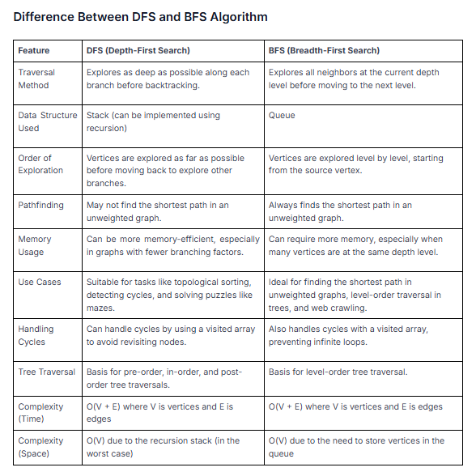
Sorting
https://www.w3schools.com/dsa/dsa_algo_bubblesort.php
Bubble sort
How it works:
- Go through the array, one value at a time.
- For each value, compare the value with the next value.
- If the value is higher than the next one, swap the values so that the highest value comes last.
- Go through the array as many times as there are values in the array.

Complexity Analysis of Bubble Sort:
Time complexity: O(n2)
Auxiliary Space: O(1)
- Bubble sort is easy to understand and implement.
- It does not require any additional memory space.
- It is a stable sorting algorithm, meaning that elements with the same key value maintain their relative order in the sorted output.

Selection Sort
Selection Sort is a comparison-based sorting algorithm. It sorts by repeatedly selecting the smallest (or largest) element from the unsorted portion and swapping it with the first unsorted element.
- Find the smallest element and swap it with the first element. This way we get the smallest element at its correct position.
- Then find the smallest among remaining elements (or second smallest) and swap it with the second element.
- We keep doing this until we get all elements moved to correct position.

It requires less number of swaps (or memory writes) compared to many other standard algorithms.
- Does not maintain the relative order of equal elements which means it is not stable.
- Heap Sort algorithm is based on Selection Sort.

Selection Sort doesn’t require extra memory. Selection Sort is an in-place sorting algorithm and requires only O(1) additional space.

Selection Sort selects the minimum element and places it in the correct position with fewer swaps, while Bubble Sort repeatedly swaps adjacent elements to sort the array.

Insertion Sort
- Start with the second element as the first element is assumed to be sorted.
- Compare the second element with the first if the second is smaller then swap them.
- Move to the third element, compare it with the first two, and put it in its correct position
- Repeat until the entire array is sorted.

Time Complexity
- Best case: O(n), If the list is already sorted, where n is the number of elements in the list.
- Average case: O(n2), If the list is randomly ordered
- Worst case: O(n2), If the list is in reverse order

Space Complexity
- Auxiliary Space: O(1), Insertion sort requires O(1) additional space, making it a space-efficient sorting algorithm.
- Space-efficient as it is an in-place algorithm.
- Adoptive. the number of inversions is directly proportional to number of swaps. For example, no swapping happens for a sorted array and it takes O(n) time only.
insertion sort is an in-place sorting algorithm.
nsertion sort is a stable sorting algorithm.
Merge Sort
- Divide: Divide the list or array recursively into two halves until it can no more be divided.
- Conquer: Each subarray is sorted individually using the merge sort algorithm.
- Merge: The sorted subarrays are merged back together in sorted order. The process continues until all elements from both subarrays have been merged.

Time Complexity:
- Best Case: O(n log n), When the array is already sorted or nearly sorted.
- Average Case: O(n log n), When the array is randomly ordered.
- Worst Case: O(n log n), When the array is sorted in reverse order.
Auxiliary Space: O(n), Additional space is required for the temporary array used during merging.

Quick Sort
- Choose a Pivot: Select an element from the array as the pivot. The choice of pivot can vary (e.g., first element, last element, random element, or median).
- Partition the Array: Re arrange the array around the pivot. After partitioning, all elements smaller than the pivot will be on its left, and all elements greater than the pivot will be on its right.
- Recursively Call: Recursively apply the same process to the two partitioned sub-arrays.
- Base Case: The recursion stops when there is only one element left in the sub-array, as a single element is already sorted.

